Elastic Cloud Configuration

1. We can create elastic cloud free trial for 14 days without any credit card. Visit <https://www.elastic.co/cloud/elasticsearch-service/signup> and signup with any gmail. In my case if used my personal gmail id.
2. Give a deployment name and it will create a instance and also create a ID and password. Save it for later use. I have deployed this on AWS. You will be given choice for Azure and GCP as well.

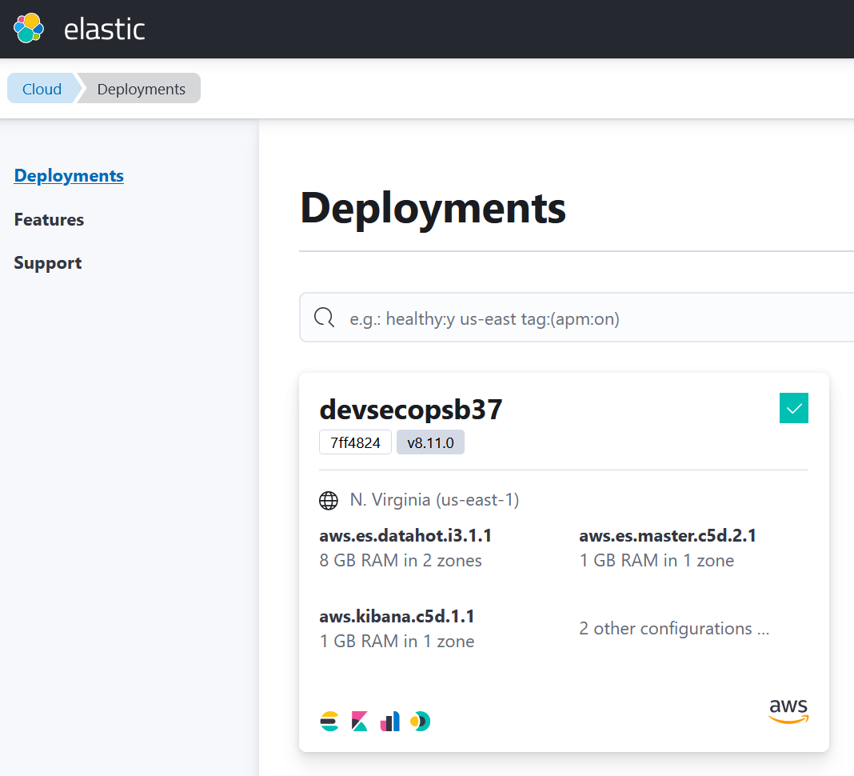

1. From the left side pane , got to Management and Click on Fleet as shown below.

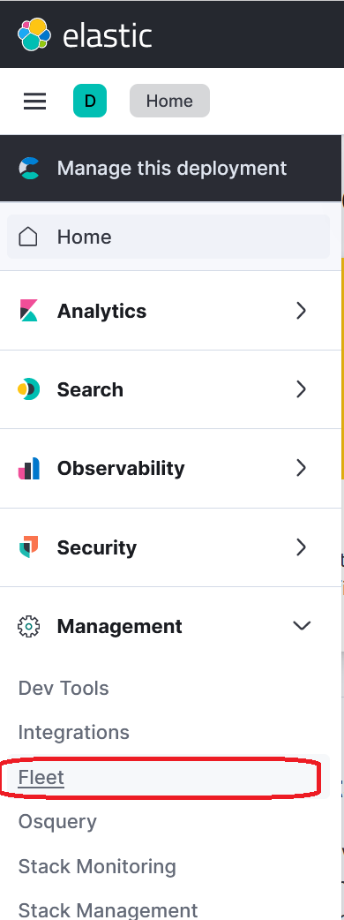

1. Select Agent Policies and Create a New Policy and give a name of you choice. Leave everything default apart from Host name format and select **Fully Qualified Domain Name (FQDN).** You will noice 0 agents as we didnt add any agents.
2. Select Integrations from Management Pane. Search for “Uptime” as shown below.

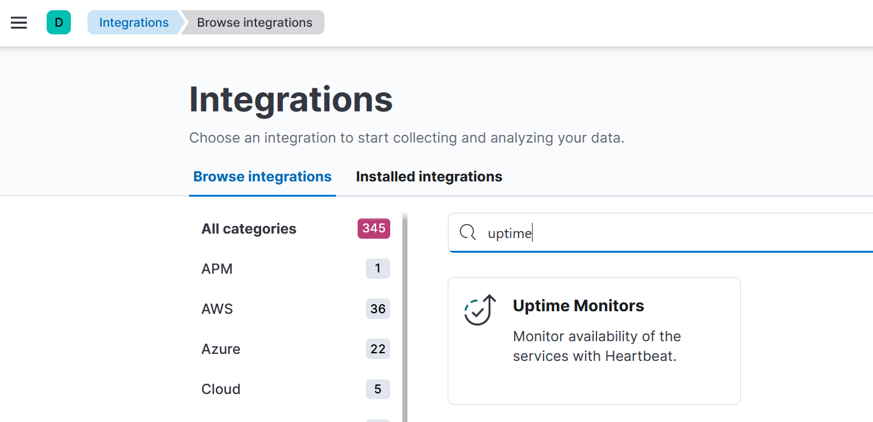

Follow the steps given for installing deb package on ubuntu and update /etc/heartbeat/heartbeat.yml as instructed and uptime should be visible.

1. Uptime can be verified from Observability → Uptime → Monitors

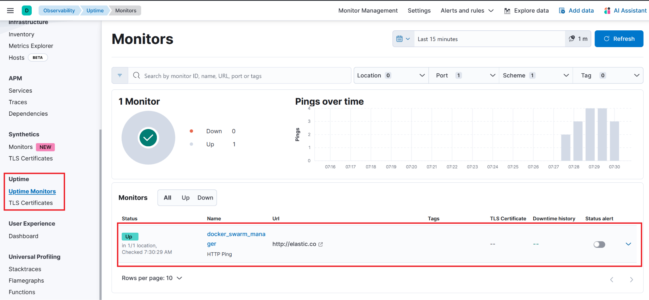

1. Run the playbook elastic_uptime.yml and it will install the elastic agent. Make sure you update API token and URL in the playvbook.
2. 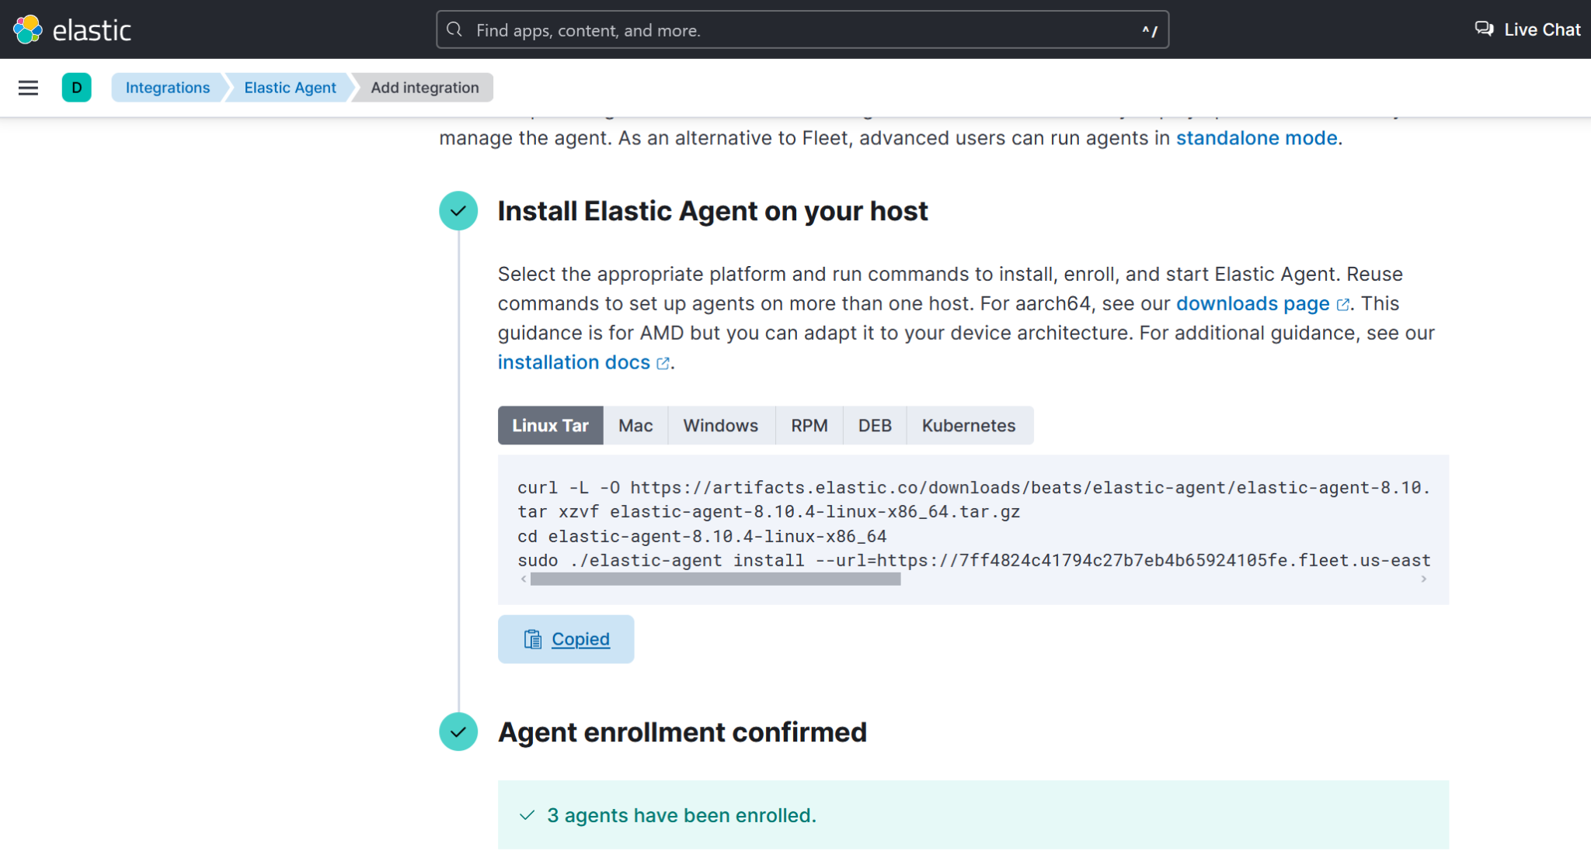

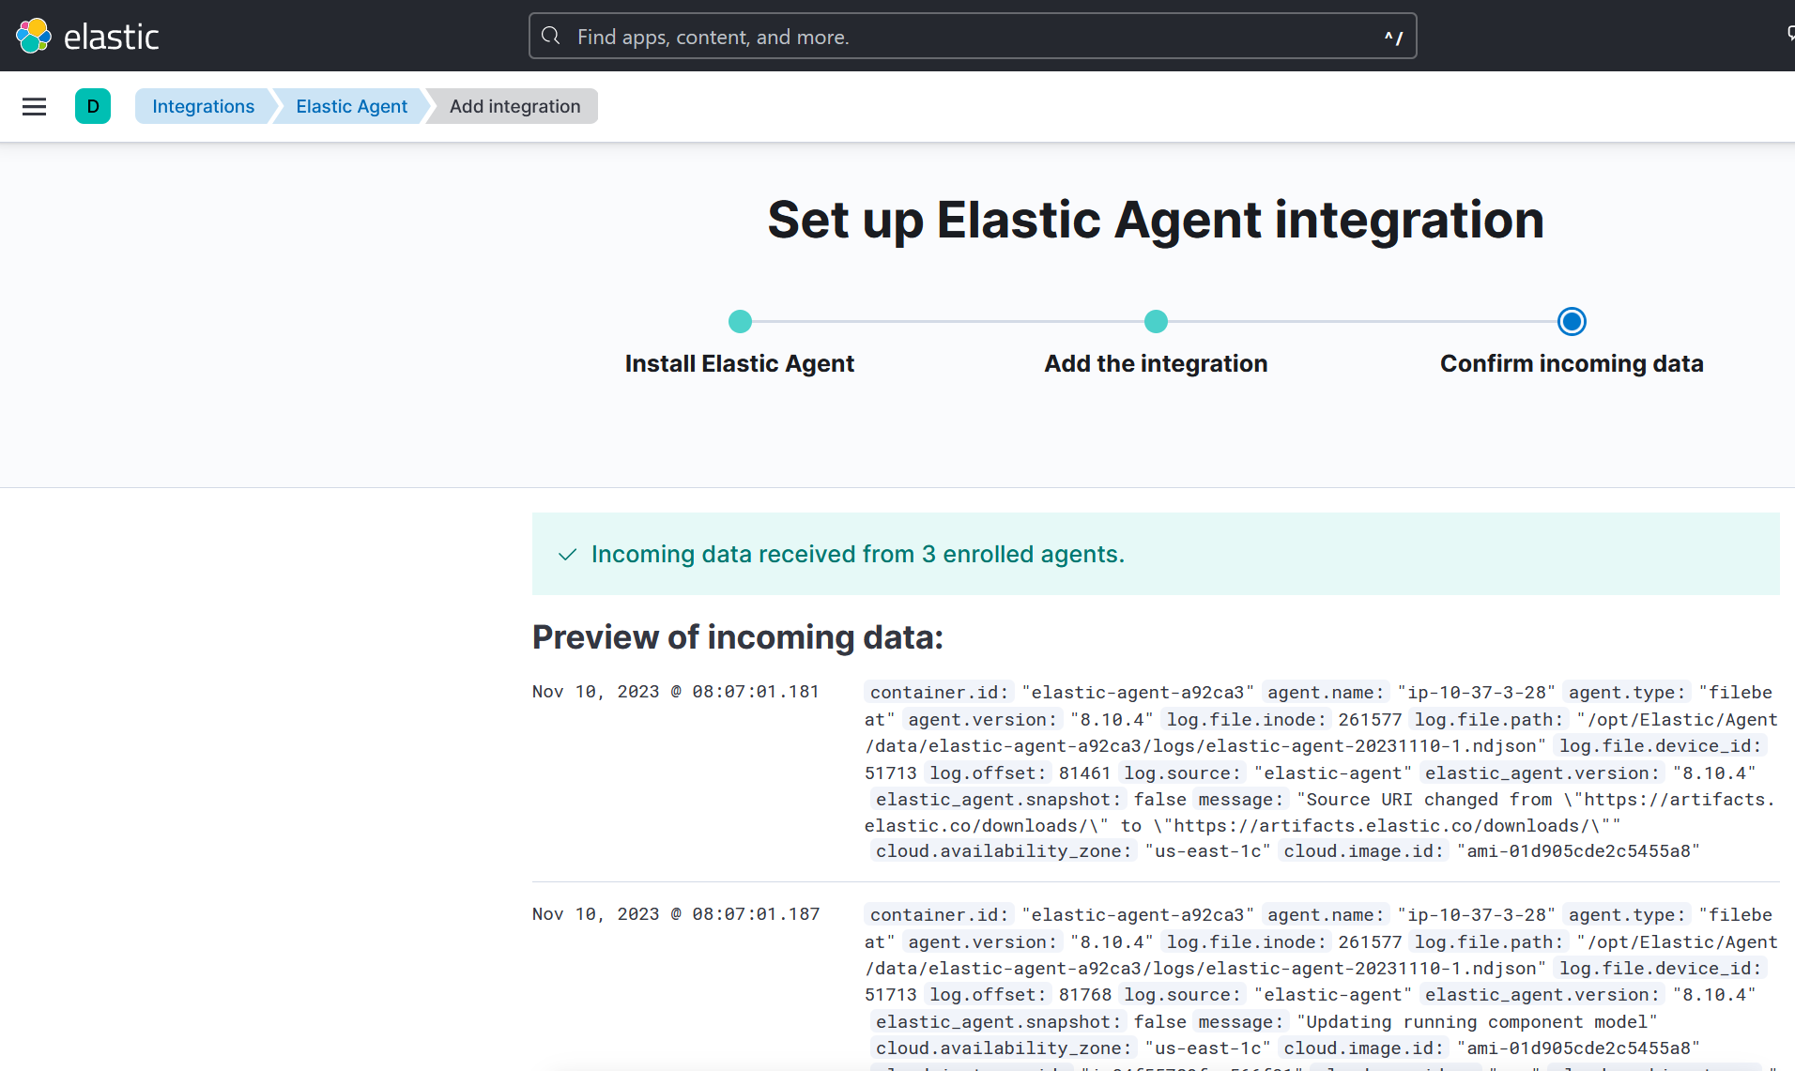

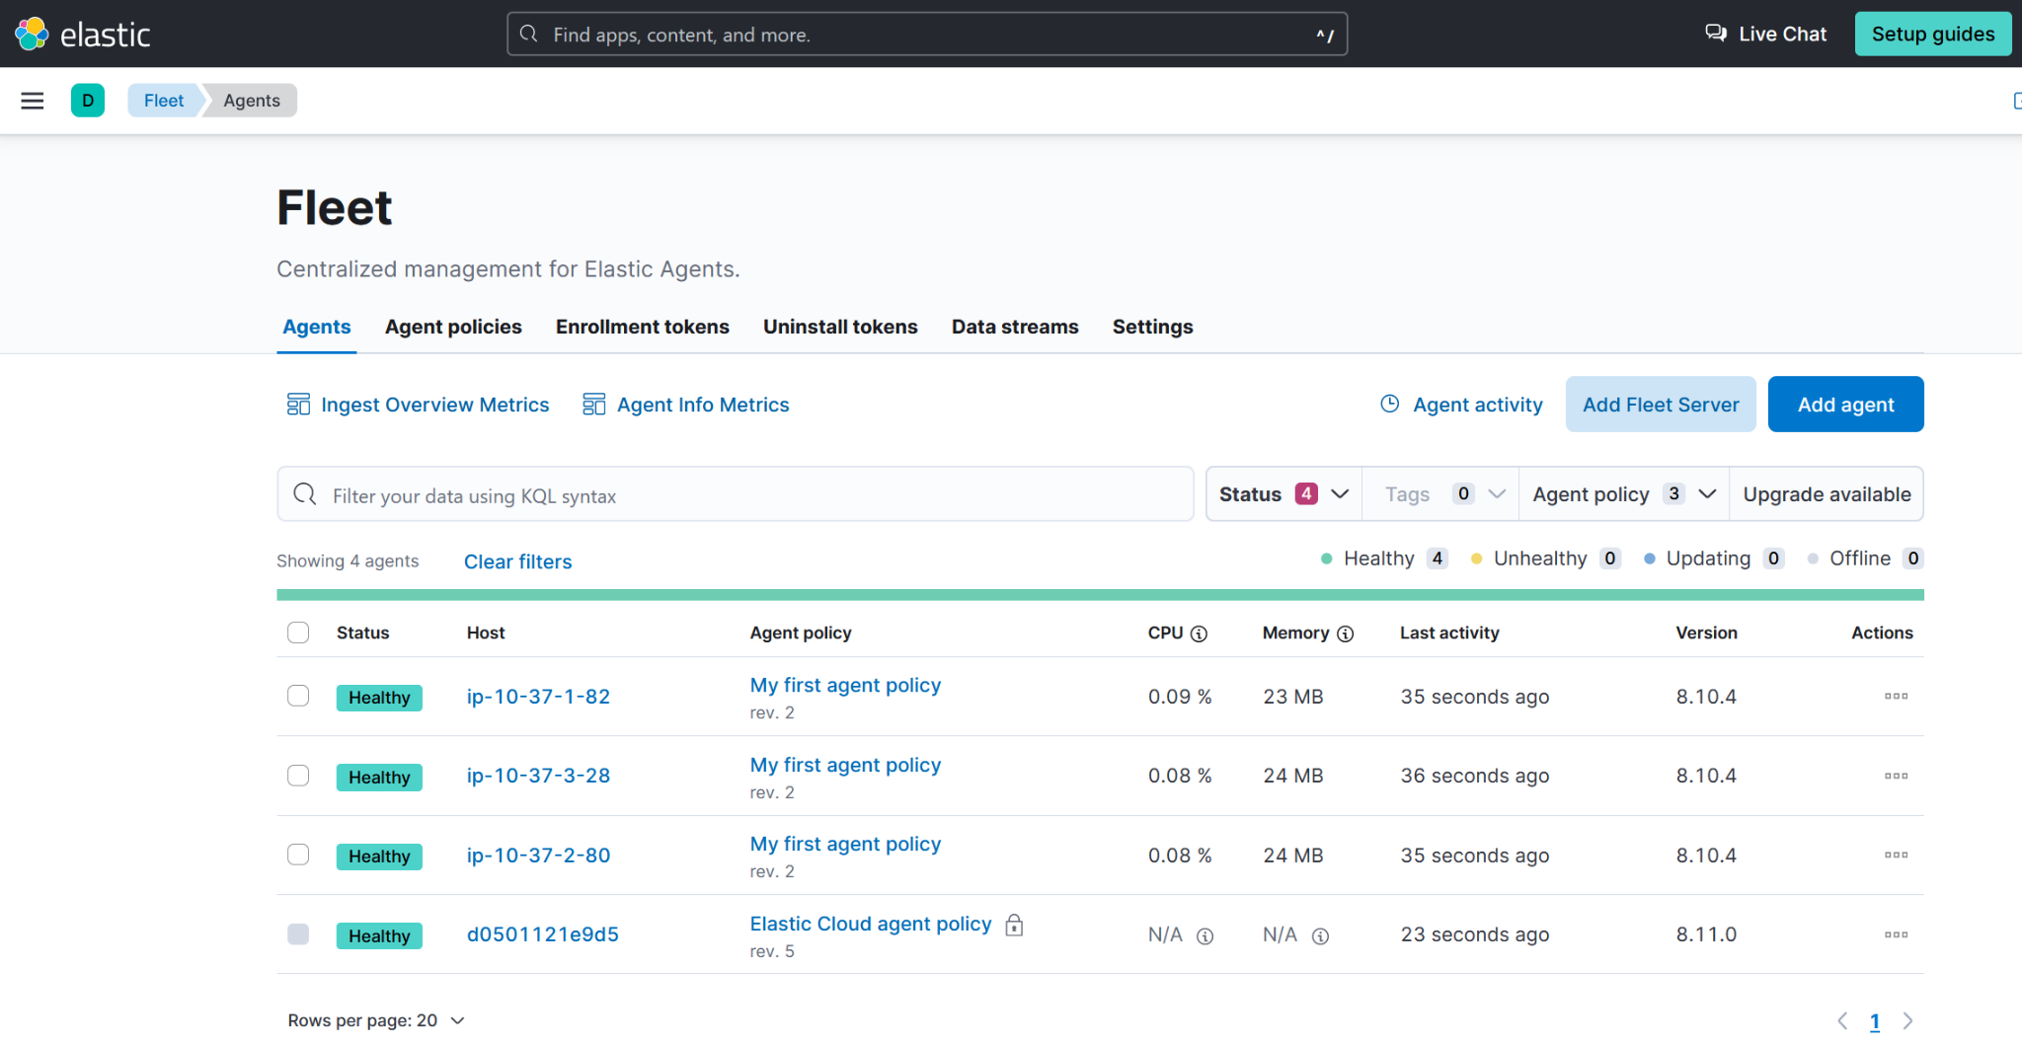

For using your custom agent policy, click the token need to be changed in the URL. Click on the custom policy and click on add integration and choose “Uptime” and next screen copy the TOKEN URL and replace in the elastic-agent playbook.

Check the status in Elastic Cloud → Observability → Infrastructure → Hosts(Beta)

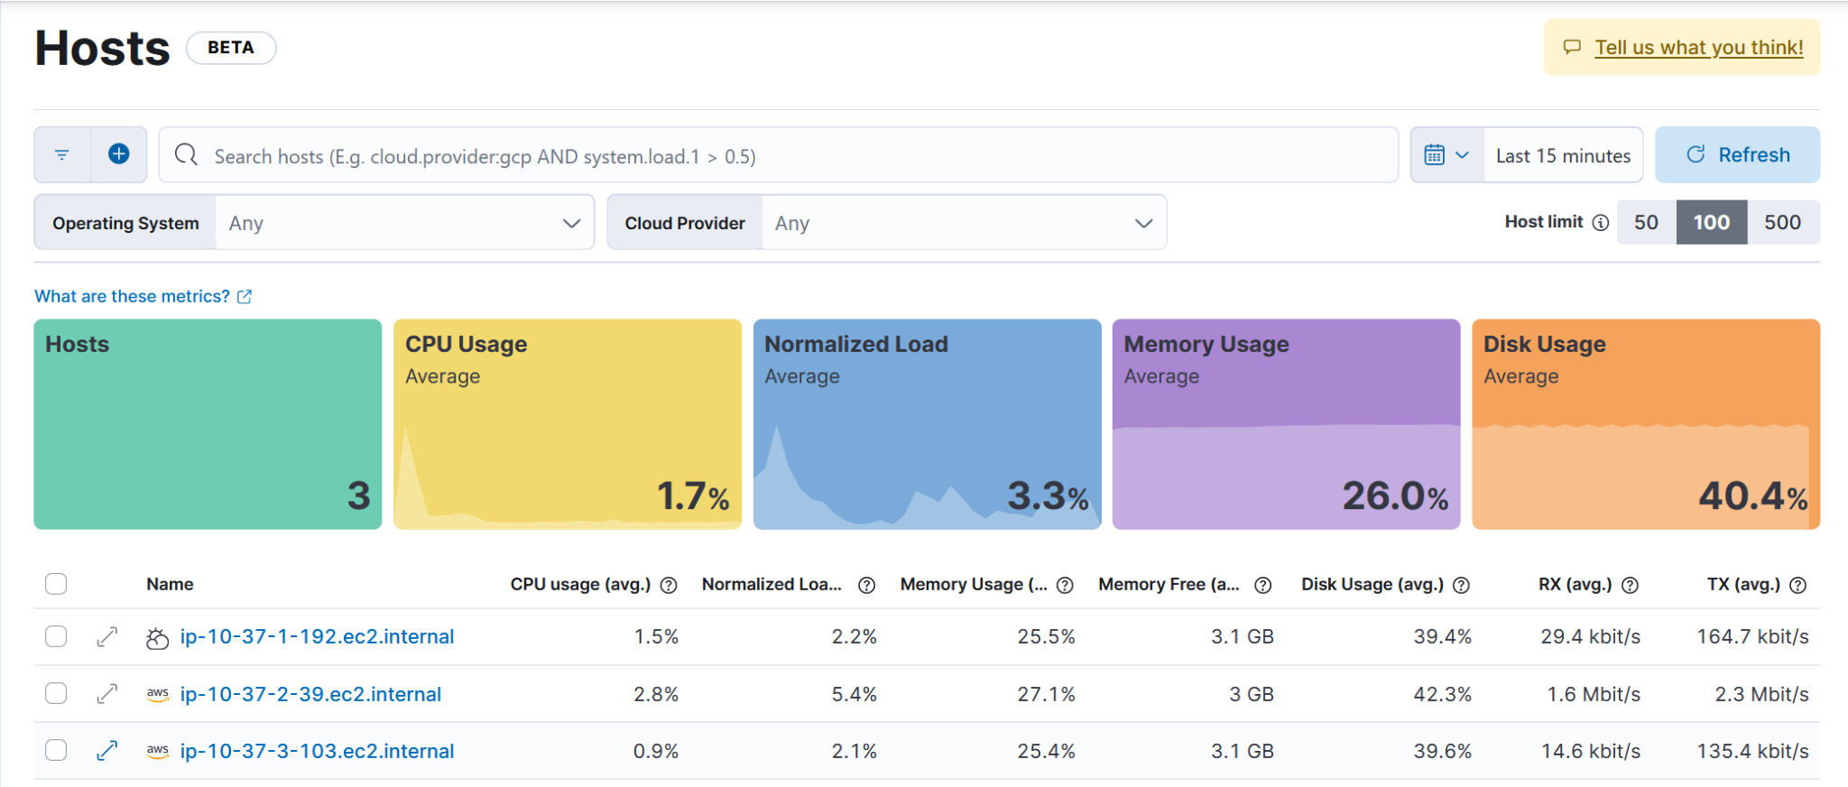

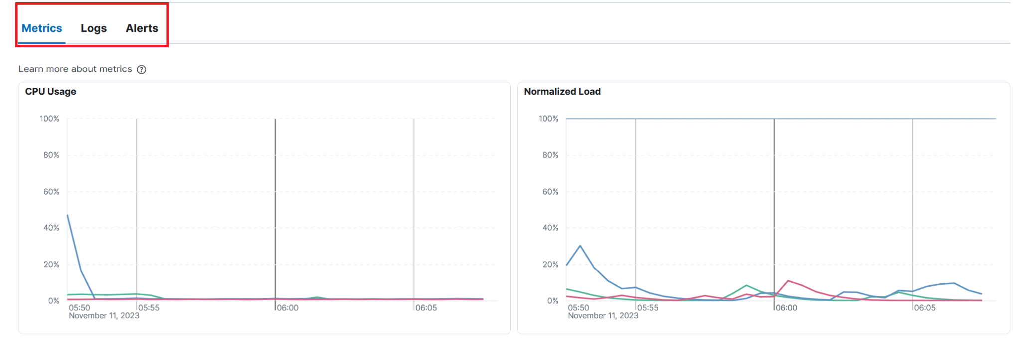

Click on the Client to get more holistic data view:

